Министерство науки и высшего образования Российской Федерации
Федеральное государственное бюджетное образовательное учреждение
высшего образования
«Рязанский государственный радиотехнический университет имени В. Ф. Уткина»
Кафедра «Вычислительная и прикладная математика»

Отчет по лабораторной работе №3
по дисциплине «Объектно-ориентированное программирование»
на тему «Наследование, статические члены, перегрузка операторов»

Выполнил: студент гр.1413
Аверкин М.Е.
Проверил: профессор
доц. Антипов О.В.

Цель работы:
Переделать 2-ую лабораторную работу, используя знания о наследование, статических членах и перегрузка операторов.
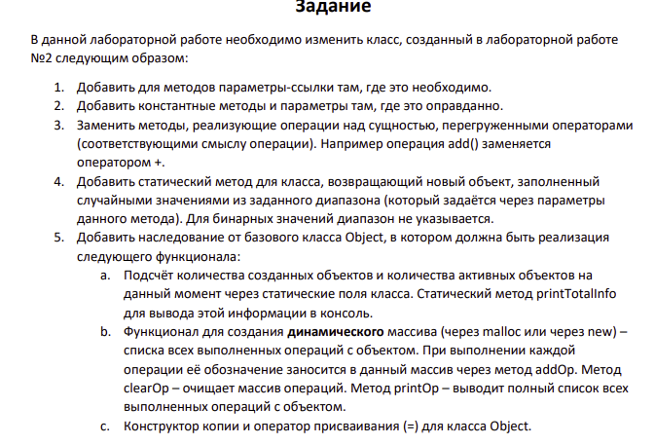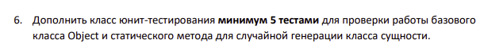
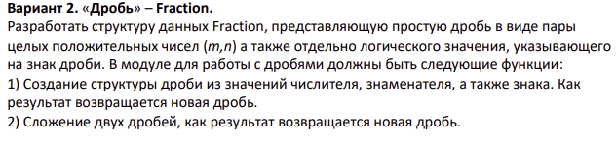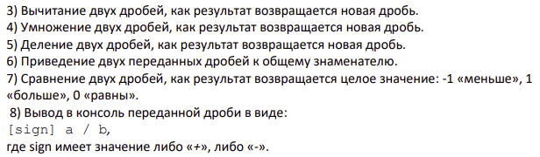

Анализ задания:
Входные данные: boolean значение, определяющее, дробь положительная или отрицательная; знаменатель дроби; числитель дроби.
В зависимости от задания: Дополнительная дробь с boolean значением, определяющим, дробь положительная или отрицательная; знаменатель дроби; числитель дроби.
Выходные данные: 15 юнит-тестов, проверяющих правильность работы программы.
Математические методы: приведение дробей к общему знаменателю, сложение дробей, умножение дробей, деление дробей, вычитание дробей, сравнение двух дробей.

Описание класса Fraction:
Класс состоит из приватных полей, содержащих целочисленное значения числителя и знаменателя, а так же логическое значение IsNegative, которое определяют, является ли дробь отрицательной или нет.
Так же определены методы в public области, требуемые по заданию.
Доступ к нестатическим полям обеспечен через Геттеры и Сеттеры.
Наследуется от класса класса Object.

Описание класса FractionTest:
Класс состоит из методов, которые проверяют верность работы методов класса Fractions и работу класса Object.

Описание класса Object:
Класс состоит из статических полей totalObj, activeObj и operationsCount, геттеров этих полей, нестатического поля-указателя *operations для хранения операций, совершенных над объектом класса. Так же необходимо определить конструктор копии и оператор присвоения для этого класса. Выступает родительским классом для класса Fractions. Определены методы AddOp, ClearOp, PrintOp для добавления, вывода и очистки списка операций, выполненных над объектом класса.

Листинг программы:

Main.cpp
#include <iostream>
#include "Fraction.h"
#include "UnitTest.h"

int main(int argc, char** argv)
{
cout << "This program tests the 1st lab" << endl;
(FractionTest()).run();

return 0;
}

Fraction.cpp
#include "Fraction.h"
#include <stdbool.h>
#include <iostream>
#include <cstdlib>

Fraction Fraction::Random(float min, float max, int seed){
Fraction resultFraction;

srand(seed);

resultFraction.numerator = min + (float)rand() / RAND_MAX * (max - min);
resultFraction.denominator = min + (float)rand() / RAND_MAX * (max - min);
resultFraction.isNegative = rand() % 2 == 1 ? false : true;

return resultFraction;
}

Fraction Fraction::Commondenominator(Fraction otherFraction){
Fraction resultFraction;
int CommonD = this->denominator * otherFraction.denominator;
resultFraction.numerator = this->numerator*otherFraction.denominator;
resultFraction.denominator = CommonD;
resultFraction.isNegative = this->isNegative;

return resultFraction;
}

Fraction Fraction::operator+(const Fraction& otherFraction){
AddOp('+');
Fraction resultFraction;

int IntSign1, IntSign2;

IntSign1 = this->Translation();

IntSign2 = otherFraction.Translation();

resultFraction.numerator = IntSign1*this->numerator + IntSign2*otherFraction.numerator;
resultFraction.denominator = this->denominator;

if (resultFraction.numerator<0){
resultFraction.isNegative = true;
resultFraction.numerator = resultFraction.numerator*(-1);
}
else{
resultFraction.isNegative = false;
}

return resultFraction;
}

Fraction Fraction::operator-(const Fraction& otherFraction){
AddOp('-');
Fraction resultFraction;

int IntSign1, IntSign2;

IntSign1 = this->Translation();

IntSign2 = otherFraction.Translation();

resultFraction.numerator = IntSign1*this->numerator - IntSign2*otherFraction.numerator;
resultFraction.denominator = this->denominator;

if (resultFraction.numerator<0){
resultFraction.isNegative = true;
resultFraction.numerator = resultFraction.numerator*(-1);
}
else{
resultFraction.isNegative = false;
}

return resultFraction;
}

Fraction Fraction::operator*(const Fraction& otherFraction){
AddOp('*');
Fraction resultFraction;

int IntSign1, IntSign2;

IntSign1 = this->Translation();

IntSign2 = otherFraction.Translation();

resultFraction.numerator = this->numerator*otherFraction.numerator;
resultFraction.denominator = this->denominator*otherFraction.denominator;
resultFraction.isNegative = IntSign1*IntSign2 < 0 ? true: false;

return resultFraction;
}

Fraction Fraction::operator/(const Fraction& otherFraction){
AddOp('/');
Fraction resultFraction;
int IntSign1, IntSign2;

IntSign1 = this->Translation();

IntSign2 = otherFraction.Translation();

resultFraction.numerator = this->numerator*otherFraction.denominator;
resultFraction.denominator = this->denominator*otherFraction.numerator;
resultFraction.isNegative = IntSign1*IntSign2 < 0 ? true: false;

return resultFraction;
}

int Fraction::operator&(const Fraction& otherFraction){
AddOp('&');
int Comparison;
int IntSign1, IntSign2;

IntSign1 = this->Translation();

IntSign2 = otherFraction.Translation();

if (IntSign1*this->numerator > IntSign2*otherFraction.numerator){
Comparison = 1;
}
else if (IntSign1*this->numerator < IntSign2*otherFraction.numerator){
Comparison = -1;
}
else
Comparison = 0;

return Comparison;
}

Fraction.h

#pragma once
#include "Object.h"
#include <stdbool.h>
#include <iostream>

using namespace std;

class Fraction: public Object
{
private:
int numerator;
int denominator;
bool isNegative;
public:
int Translation () const{
int IntSign;
IntSign = this->isNegative ? -1 : 1;
return IntSign;
}

Fraction(int numerator,int denominator, bool isNegative){
this->numerator = numerator;
this->denominator = denominator;
this->isNegative = isNegative;
}

Fraction() {
}

static Fraction Random(float min, float max, int seed = 0);

int GetNum() const {
return numerator;
}
int GetDen() const {
return denominator;
}
bool GetisNeg() const {
return isNegative;
}

void SetNum( int _numerator){
numerator = _numerator;
}

void SetDen(int _denominator){
denominator = _denominator;
}

void SetisNeg(bool _isNegative){
isNegative = _isNegative;
}

int Comparison(Fraction otherFraction){
return (this->numerator == otherFraction.numerator) == (this->denominator == otherFraction.denominator) == (this->isNegative == otherFraction.isNegative);
}

Fraction operator+(const Fraction& otherFraction);
Fraction operator-(const Fraction& otherFraction);
Fraction operator*(const Fraction& otherFraction);
Fraction operator/(const Fraction& otherFraction);
int operator&(const Fraction& otherFraction);

void PrintFraction() const{
this->isNegative ? cout << '-': cout << '+';
cout << '(' << this->numerator << '/' << this->denominator << ')' << endl;
}

Fraction Commondenominator(Fraction otherFraction);
};

UnitTest.cpp

#include "UnitTest.h"

void FractionTest::run()
{
startTest();

updateTestResult(CommondenominatorTest1());
updateTestResult(CommondenominatorTest2());
updateTestResult(SumFractionsTest1());
updateTestResult(SumFractionsTest2());
updateTestResult(SubFractionsTest1());
updateTestResult(SubFractionsTest2());
updateTestResult(DivFractionsTest());
updateTestResult(MultFractionsTest1());
updateTestResult(MultFractionsTest2());
updateTestResult(CompFractionsTest());

updateTestResult(RandomFractionsTest1());
updateTestResult(RandomFractionsTest2());
updateTestResult(PrintTotalInfoTestA());
updateTestResult(PrintTotalInfoTestT());
updateTestResult(PrintOpTest());

printTestResults();
}

void FractionTest::printTestResults()
{
cout << "Test results passed: " << testPassed << " of " << testTotal << endl;
}

void FractionTest::updateTestResult(bool passed)
{
if(passed)
++testPassed, cout << "Success!" << endl;
else
cout << "Failure!" << endl;
cout << endl;
}

bool FractionTest::assertValueVal(int actual, int expected)
{
cout << "Expected Result: " << expected << endl;
cout << "Actual result: " << actual << endl;
return actual == expected;
}

bool FractionTest::assertValueFrac(Fraction actual, Fraction expected)
{
cout << "Expected Result: ";
expected.PrintFraction();
cout << "Actual result: ";
actual.PrintFraction();
return actual.Comparison(expected);
}

bool FractionTest::CommondenominatorTest1(){
cout << "(1)Testing the Commondenominator: fractions must be reduced to a common denominator" << endl;

int arrangeNumerator = 28;
int arrangeDenominator = 12;
bool arrangeIsNegative = true;

int referenceNumerator1 = 7;
int referenceDenominator1 = 3;
bool referenceIsNegative1 = true;
Fraction Fraction1 = Fraction(referenceNumerator1,referenceDenominator1,referenceIsNegative1);

int referenceNumerator2 = 3;
int referenceDenominator2 = 4;
bool referenceIsNegative2 = false;
Fraction Fraction2 = Fraction(referenceNumerator2,referenceDenominator2,referenceIsNegative2);

//must be
Fraction TestFraction = Fraction(arrangeNumerator,arrangeDenominator,arrangeIsNegative);

//do
Fraction ComFraction1 = Fraction1.Commondenominator(Fraction2);
Fraction ComFraction2 = Fraction2.Commondenominator(Fraction1);

//result
return assertValueFrac(TestFraction,ComFraction1);
}

bool FractionTest::CommondenominatorTest2(){
cout << "(2)Testing the Commondenominator: fractions must be reduced to a common denominator" << endl;

int arrangeNumerator = 9;
int arrangeDenominator = 12;
bool arrangeIsNegative = false;

int referenceNumerator1 = 7;
int referenceDenominator1 = 3;
bool referenceIsNegative1 = true;
Fraction Fraction1 = Fraction(referenceNumerator1,referenceDenominator1,referenceIsNegative1);

int referenceNumerator2 = 3;
int referenceDenominator2 = 4;
bool referenceIsNegative2 = false;
Fraction Fraction2 = Fraction(referenceNumerator2,referenceDenominator2,referenceIsNegative2);

//must be
Fraction TestFraction = Fraction(arrangeNumerator,arrangeDenominator,arrangeIsNegative);

//do
Fraction ComFraction1 = Fraction1.Commondenominator(Fraction2);
Fraction ComFraction2 = Fraction2.Commondenominator(Fraction1);

//result
return assertValueFrac(TestFraction,ComFraction2);
}

bool FractionTest::SumFractionsTest1(){
cout << "(1) Sum Check: Calculations must be correct." << endl;

int arrangeNumerator = 19;
int arrangeDenominator = 12;
bool arrangeIsNegative = true;

int referenceNumerator1 = 7;
int referenceDenominator1 = 3;
bool referenceIsNegative1 = true;
Fraction Fraction1 = Fraction(referenceNumerator1,referenceDenominator1,referenceIsNegative1);

int referenceNumerator2 = 3;
int referenceDenominator2 = 4;
bool referenceIsNegative2 = false;
Fraction Fraction2 = Fraction(referenceNumerator2,referenceDenominator2,referenceIsNegative2);

Fraction ComFraction1 = Fraction1.Commondenominator(Fraction2);
Fraction ComFraction2 = Fraction2.Commondenominator(Fraction1);

//must be
Fraction TestFraction = Fraction(arrangeNumerator,arrangeDenominator,arrangeIsNegative);

//do
Fraction resultFraction = ComFraction1+(ComFraction2);

//result
return assertValueFrac(TestFraction,resultFraction);
}

bool FractionTest::SumFractionsTest2(){
cout << "(2) Sum Check: Calculations must be correct." << endl;

int arrangeNumerator = 37;
int arrangeDenominator = 12;
bool arrangeIsNegative = true;

int referenceNumerator1 = 7;
int referenceDenominator1 = 3;
bool referenceIsNegative1 = true;
Fraction Fraction1 = Fraction(referenceNumerator1,referenceDenominator1,referenceIsNegative1);

int referenceNumerator2 = 3;
int referenceDenominator2 = 4;
bool referenceIsNegative2 = true;
Fraction Fraction2 = Fraction(referenceNumerator2,referenceDenominator2,referenceIsNegative2);

Fraction ComFraction1 = Fraction1.Commondenominator(Fraction2);
Fraction ComFraction2 = Fraction2.Commondenominator(Fraction1);

//must be
Fraction TestFraction = Fraction(arrangeNumerator,arrangeDenominator,arrangeIsNegative);

//do
Fraction resultFraction = ComFraction1+(ComFraction2);

//result
return assertValueFrac(TestFraction,resultFraction);
}

bool FractionTest::SubFractionsTest1(){
cout << "(1) Subtraction check: Calculations must be correct." << endl;

int arrangeNumerator = 19;
int arrangeDenominator = 12;
bool arrangeIsNegative = true;

int referenceNumerator1 = 7;
int referenceDenominator1 = 3;
bool referenceIsNegative1 = true;
Fraction Fraction1 = Fraction(referenceNumerator1,referenceDenominator1,referenceIsNegative1);

int referenceNumerator2 = 3;
int referenceDenominator2 = 4;
bool referenceIsNegative2 = true;
Fraction Fraction2 = Fraction(referenceNumerator2,referenceDenominator2,referenceIsNegative2);

Fraction ComFraction1 = Fraction1.Commondenominator(Fraction2);
Fraction ComFraction2 = Fraction2.Commondenominator(Fraction1);

//must be
Fraction TestFraction = Fraction(arrangeNumerator,arrangeDenominator,arrangeIsNegative);

//do
Fraction resultFraction = ComFraction1-(ComFraction2);

//result
return assertValueFrac(TestFraction,resultFraction);
}

bool FractionTest::SubFractionsTest2(){
cout << "(2) Subtraction check: Calculations must be correct." << endl;

int arrangeNumerator = 37;
int arrangeDenominator = 12;
bool arrangeIsNegative = true;

int referenceNumerator1 = 7;
int referenceDenominator1 = 3;
bool referenceIsNegative1 = true;
Fraction Fraction1 = Fraction(referenceNumerator1,referenceDenominator1,referenceIsNegative1);

int referenceNumerator2 = 3;
int referenceDenominator2 = 4;
bool referenceIsNegative2 = false;
Fraction Fraction2 = Fraction(referenceNumerator2,referenceDenominator2,referenceIsNegative2);

Fraction ComFraction1 = Fraction1.Commondenominator(Fraction2);
Fraction ComFraction2 = Fraction2.Commondenominator(Fraction1);

//must be
Fraction TestFraction = Fraction(arrangeNumerator,arrangeDenominator,arrangeIsNegative);

//do
Fraction resultFraction = ComFraction1-(ComFraction2);

//result
return assertValueFrac(TestFraction,resultFraction);
}

bool FractionTest::MultFractionsTest1(){
cout << "(1) Multiplication check: Calculations must be correct." << endl;

int arrangeNumerator = 21;
int arrangeDenominator = 12;
bool arrangeIsNegative = true;

int referenceNumerator1 = 7;
int referenceDenominator1 = 3;
bool referenceIsNegative1 = true;
Fraction Fraction1 = Fraction(referenceNumerator1,referenceDenominator1,referenceIsNegative1);

int referenceNumerator2 = 3;
int referenceDenominator2 = 4;
bool referenceIsNegative2 = false;
Fraction Fraction2 = Fraction(referenceNumerator2,referenceDenominator2,referenceIsNegative2);

//must be
Fraction TestFraction = Fraction(arrangeNumerator,arrangeDenominator,arrangeIsNegative);

//do
Fraction resultFraction = Fraction1*(Fraction2);

//result
return assertValueFrac(TestFraction,resultFraction);
}

bool FractionTest::MultFractionsTest2(){
cout << "(2) Multiplication check: Calculations must be correct." << endl;

int arrangeNumerator = 21;
int arrangeDenominator = 12;
bool arrangeIsNegative = false;

int referenceNumerator1 = 7;
int referenceDenominator1 = 3;
bool referenceIsNegative1 = true;
Fraction Fraction1 = Fraction(referenceNumerator1,referenceDenominator1,referenceIsNegative1);

int referenceNumerator2 = 3;
int referenceDenominator2 = 4;
bool referenceIsNegative2 = true;
Fraction Fraction2 = Fraction(referenceNumerator2,referenceDenominator2,referenceIsNegative2);

//must be
Fraction TestFraction = Fraction(arrangeNumerator,arrangeDenominator,arrangeIsNegative);

//do
Fraction resultFraction = Fraction1*(Fraction2);

//result
return assertValueFrac(TestFraction,resultFraction);
}

bool FractionTest::DivFractionsTest(){
cout << "(1) Division check: Calculations must be correct." << endl;

int arrangeNumerator = 9;
int arrangeDenominator = 28;
bool arrangeIsNegative = true;

int referenceNumerator1 = 7;
int referenceDenominator1 = 3;
bool referenceIsNegative1 = false;
Fraction Fraction1 = Fraction(referenceNumerator1,referenceDenominator1,referenceIsNegative1);

int referenceNumerator2 = 3;
int referenceDenominator2 = 4;
bool referenceIsNegative2 = true;
Fraction Fraction2 = Fraction(referenceNumerator2,referenceDenominator2,referenceIsNegative2);

//must be
Fraction TestFraction = Fraction(arrangeNumerator,arrangeDenominator,arrangeIsNegative);

//do
Fraction resultFraction = Fraction1/(Fraction2);

//result
return assertValueFrac(TestFraction,resultFraction);
}

bool FractionTest::CompFractionsTest(){
cout << "(1) Comparison check: should output 1." << endl;

int referenceNumerator1 = 7;
int referenceDenominator1 = 3;
bool referenceIsNegative1 = false;
Fraction Fraction1 = Fraction(referenceNumerator1,referenceDenominator1,referenceIsNegative1);

int referenceNumerator2 = 3;
int referenceDenominator2 = 4;
bool referenceIsNegative2 = true;
Fraction Fraction2 = Fraction(referenceNumerator2,referenceDenominator2,referenceIsNegative2);

Fraction ComFraction1 = Fraction1.Commondenominator(Fraction2);
Fraction ComFraction2 = Fraction2.Commondenominator(Fraction1);

//must be
int TestComparison = 1;

//do
int Comparison = ComFraction1&ComFraction2;

//result
return assertValueVal(TestComparison,Comparison);
}

bool FractionTest::RandomFractionsTest1(){
cout << "(1)Random check:" << endl;

int RightNumerator = 5;
int RightDenominator = 1;
bool RightIsNegative = false;
Fraction RightFraction = Fraction(RightNumerator,RightDenominator,RightIsNegative);

int LeftNumerator = 5;
int LeftDenominator = 1;
bool LeftIsNegative = true;
Fraction LeftFraction = Fraction(LeftNumerator,LeftDenominator,LeftIsNegative);

//must be
int TestComparison = 0;

//do
Fraction RanFraction = RanFraction.Random(1, 5, 1);

Fraction ComRanFraction = RanFraction.Commondenominator(RightFraction);
Fraction ComRightFraction = RightFraction.Commondenominator(RanFraction);
Fraction ComLeftFraction = LeftFraction.Commondenominator(RanFraction);

int RightComparison = ComRanFraction&ComRightFraction;
int LeftComparison = ComRanFraction&ComLeftFraction;

int Comparison = RightComparison+LeftComparison;

//result
return assertValueVal(TestComparison,Comparison);
}

bool FractionTest::RandomFractionsTest2(){
cout << "(2)Random check:" << endl;

int RightNumerator = 17;
int RightDenominator = 5;
bool RightIsNegative = false;
Fraction RightFraction = Fraction(RightNumerator,RightDenominator,RightIsNegative);

int LeftNumerator = 17;
int LeftDenominator = 5;
bool LeftIsNegative = true;
Fraction LeftFraction = Fraction(LeftNumerator,LeftDenominator,LeftIsNegative);

//must be
int TestComparison = 0;

//do
Fraction RanFraction = RanFraction.Random(5, 17, 1);

Fraction ComRanFraction = RanFraction.Commondenominator(RightFraction);
Fraction ComRightFraction = RightFraction.Commondenominator(RanFraction);
Fraction ComLeftFraction = LeftFraction.Commondenominator(RanFraction);

int RightComparison = ComRanFraction&ComRightFraction;
int LeftComparison = ComRanFraction&ComLeftFraction;

int Comparison = RightComparison+LeftComparison;

//result
return assertValueVal(TestComparison,Comparison);
}

bool FractionTest::PrintTotalInfoTestA(){
cout << "(Active Objects)Checking the output of all information:" << endl;

Fraction SFraction;
SFraction.PrintTotalInfo();
Fraction Test1 = Test1.Random(1, 100, 1);
Fraction Test2 = Test2.Random(1, 100, 1);
Fraction Test3 = Test3.Random(1, 100, 1);
Fraction Test4 = Test4.Random(1, 100, 1);
Fraction Test5 = Test5.Random(1, 100, 1);
//must be
int TestAObj = 6;
cout<< "there was 1 object and 5 objects were added"<<endl;
//do
int EndAC = SFraction.GetAObj();
SFraction.PrintTotalInfo();

return assertValueVal(TestAObj,EndAC);
}

bool FractionTest::PrintTotalInfoTestT(){
cout << "(Total Objects)Checking the output of all information:" << endl;

Fraction SFraction;
int StarTC = SFraction.GetTObj();
SFraction.PrintTotalInfo();
Fraction Test1 = Test1.Random(1, 100, 1);
Fraction Test2 = Test2.Random(1, 100, 1);
Fraction Test3 = Test3.Random(1, 100, 1);
Fraction Test4 = Test4.Random(1, 100, 1);
Fraction Test5 = Test5.Random(1, 100, 1);

//must be
int TesCTObj = 5;
cout<< "Added 5 objects"<<endl;

//do
int EndTC = SFraction.GetTObj();
int ResCTObj = EndTC - StarTC;
SFraction.PrintTotalInfo();

return assertValueVal(TesCTObj,ResCTObj);
}

bool FractionTest::PrintOpTest(){
cout << "Checking the output of information about operators:" << endl;

//must be
int TestCOp = 4;

//do
Fraction RanFraction1 = RanFraction1.Random(5, 17, 0);

Fraction RanFraction2 = RanFraction2.Random(1, 15, 0);

Fraction ResultFrac = RanFraction1+RanFraction2;
ResultFrac = RanFraction1-RanFraction2;
ResultFrac = RanFraction1*RanFraction2;
ResultFrac = RanFraction1/RanFraction2;

RanFraction1.PrintOp();
int COp = RanFraction1.GetCOp();

return assertValueVal(TestCOp,COp);
}

UnitTest.h

#pragma once

#include "Fraction.h"
#include <stdbool.h>
#include <iostream>

class FractionTest{
const int testTotal = 15;
int testPassed = 0;

void startTest() { testPassed = 0; }
bool assertValueFrac(Fraction actual, Fraction expected);
bool assertValueVal(int actual, int expected);
void updateTestResult(bool passed);
void printTestResults();

bool CommondenominatorTest1();
bool CommondenominatorTest2();
bool SumFractionsTest1();
bool SumFractionsTest2();
bool SubFractionsTest1();
bool SubFractionsTest2();
bool MultFractionsTest1();
bool MultFractionsTest2();
bool DivFractionsTest();
bool CompFractionsTest();

bool RandomFractionsTest1();
bool RandomFractionsTest2();
bool PrintTotalInfoTestA();
bool PrintTotalInfoTestT();
bool PrintOpTest();

public:

void run();
};

Object.cpp

#include "Object.h"
#include <iostream>

int Object::totalObj = 0;
int Object::activeObj = 0;

Object::Object()
{
++totalObj;
++activeObj;
}

Object::~Object()
{
--activeObj;
ClearOp();
}

void Object::ClearOp()
{
delete[] operations;
operations = nullptr;
operationsCount = 0;
}

void Object::PrintTotalInfo()
{
cout << endl;
cout << "Total objects: " << totalObj << endl;
cout << "Active objects: " << activeObj << endl;
cout << endl;
}

void Object::PrintOp() const
{
cout << "Operations: ";
for (int i = 0; i < operationsCount; ++i)
{
cout << operations[i] << " ";
}
cout << endl;
}

Object::Object(const Object& otherFraction)
: operationsCount(otherFraction.operationsCount)
{
++totalObj;
++activeObj;

operations = new char[operationsCount];
memcpy(operations, otherFraction.operations, operationsCount);
}

Object& Object::operator=(const Object& otherFraction)
{
if (this == &otherFraction)
{
return *this;
}

ClearOp();

operationsCount = otherFraction.operationsCount;

operations = new char[operationsCount];
memcpy(operations, otherFraction.operations, operationsCount);

return *this;
}

void Object::AddOp(char op)
{
++operationsCount;

char* newOperations = new char[operationsCount];
memcpy(newOperations, operations, operationsCount - 1);
newOperations[operationsCount - 1] = op;

delete[] operations;
operations = newOperations;
}

Object.h
#pragma once
using namespace std;

class Object
{
private:
static int totalObj;
static int activeObj;
char* operations = nullptr;
int operationsCount = 0;

public:

int GetTObj() const {
return totalObj;
}

int GetAObj() const {
return activeObj;
}

int GetCOp() const {
return operationsCount;
}

Object();
Object(const Object& otherFraction);
Object& operator=(const Object& otherFraction);
virtual ~Object();

static void PrintTotalInfo();

void AddOp(char op);
void ClearOp();
void PrintOp() const;
};

Результаты работы программы:
Все проведенные юнит-тесты(15шт):
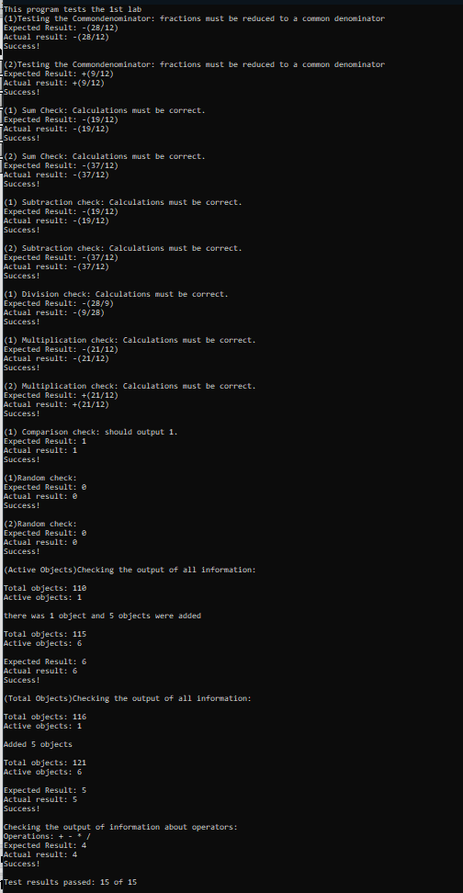

Вывод:
Я освоил работу с объектами. Понял механизм работы с наследованием, статическими членами и перегрузкой операторов.

